**Levels of Analysis (Module)**

**Module: Introduction to Psychology**

**Subtopic: Psychology is a Diverse Field**-teaches us how we think, feel, develop, learn, love, interact and grow; teaches us who we are

**Subtopic: Psychology as a Science**-experimental psychology used the scientific method to collect, evaluate and interpret information to draw sound conclusions--

**Subtopic: Conclusions**-psychology has been influences by several schools of thought which have each introduced new questions, tools, and perspectives  
-different views sometimes clash leading to great debates about such fundamental concerns as what should be the focus of psych­­­­ology

**Module: A Brief History of Psychology**

**Subtopic: Psychology’s Parents**-Ebbinghaus (psychology had a long past but a short history)  
-throughout its history, the integration of new schools of thought and technological innovations have driven the field forward in the quest to solve some of the oldest puzzles in science and philosophy  
-**Psychology:** the term psychology comes from the Greek words “psyche”, which means soul  
-philosophers such as Aristotle and Plate contemplated fundamental questions of “how do we learn and remember?”  
-Rene Descartes suggested that the mind and body were distinct entities that were casually linked in a dualistic relationship: the mind in turn received information about the outside world through sense organs  
-Muller proposed that like an electrical current flowing along a metal conductor, the messages transmitted by nerves were coded as electrical impulses that travelled along different channels  
-Muller further explained that particular parts of the body are connected to specific areas of the brain to serve different functions  
-Fluorens experiments supported this idea and used a technique to systematically destroy different regions of an animal’s brain (from this, he learned which brain regions control heart rate, breathing, and processes of visual and auditory reflexes)

**Subtopic: Psychology as an Independent Field**-William Wundt opened first lab dedicated to psychology; believed that conscious experience could be studied using the same rigorous experimental tools that chemists and physicists use to study their research ­­questions, then published psychology journal  
-Stanley Hall (Wundt’s student) opened first psychology laboratory in North America and founded the American Psychological Association

**Subtopic: Looking Ahead  
-**modern approach to questions of Psychology draws on expertise from many converging fields including: physical, biological, chemical, social, mathematical and computer sciences (this approach is reflected in the multiple levels of analyses and perspectives used to view problems in psychology)

**Module: Introduction to Levels of Analysis**

**Subtopic: Multiple Levels of Analysis  
-**three basic levels of analyses: Psychological, Biological and Environmental

**Subtopic: Introduction to Psychological Analysis  
-**most intuitive level to approach an understanding of human thought and behaviour  
-concerns itself with the role of what lies within a subjects mind: how so thoughts, memories, and emotions motivate our actions?  
-studies how emotions, memories and patterns of thinking lie at the core of the problem

**Subtopic: Introduction to Biological Analysis  
-**focus on the physiological mechanisms that underlie thoughts and behaviour  
-may include structure and function of the brain, the molecular effects of neurotransmitters and hormones, and how genetic factors contribute to behaviour  
-studies role of key neurotransmitters such as serotonin in mood disorders and genetic factors that make some individuals more prone to certain illnesses or disorders

**Subtopic: Introduction to the Environmental Analysis  
-**concerned with understanding how social, cultural, and learning interactions can influence thought and behaviour  
-study the conditions that triggered and maintain feelings (ex: depression); in this manner, working to change these external influences may bring out positive changes

**Module: Introduction to Perspectives in Psychology**

**Subtopic: Multiple Perspectives  
-**from broad view, psychologist can choose from levels of analysis to help frame research questions but more specifically, a problem can be approached from a perspective which has specific goals and involved one or more of these levels of analysis  
- some commonly used perspectives include: behavioural, evolution, neuroscience, social cultural, cognitive and development

**Subtopic: Behavioural Perspective  
-**father of behaviourism, Watson  
-according to perspective, overt behaviour is the *only* valid means of measure in psychology  
-Watson argues that scientists should consider the mine to be an off limits “black box” that takes input and makes output  
-what actually happens inside the “black box” should be considered to be outside the domain of science  
-researchers focusing on this perspective focus on designing carefully controlled experiments to understand the influence of the environmental level of analysis on behaviour  
-believed in Nurture over Nature (Watson)  
-Nurture over Nature was carried on by BF Skinner who conceded that although internal mental events must surely exist, they remained impossible to measure in a scientific way  
-general laws of stimulus-response could explain that an organism will repeat a behaviour if it leads to something pleasant and not repeat a behaviour if it leads to something unpleasant  
-these ideas formed the core of a therapy called behaviour modification, which is widely used in schools, factories, mental hospitals, and informally by parents and pet owners everywhere

**Module: Cognitive**

**Subtopic: The Cognitive Perspective  
-**advocates of pure behavioural perspective advised the notions of studying the internal events of the mind had to be abandoned in order for psychology to become a science  
-Cognitive Revolution argued that psychology could and must return to an interest in the internal events of the mind (under the right circumstances)  
-new movement argued that proper scientific methods can be applied to study internal mental processes that are necessary to fully understand behaviour  
-**Models:** abstract representations of how the mind functions; can be used to make predictions and design experiments; help understand functioning of a complex process such as memory  
-pure cognitive perspective operates at the psychological level of analysis  
-cognitive psychologists use models to construct abstract representations of how the mind functions  
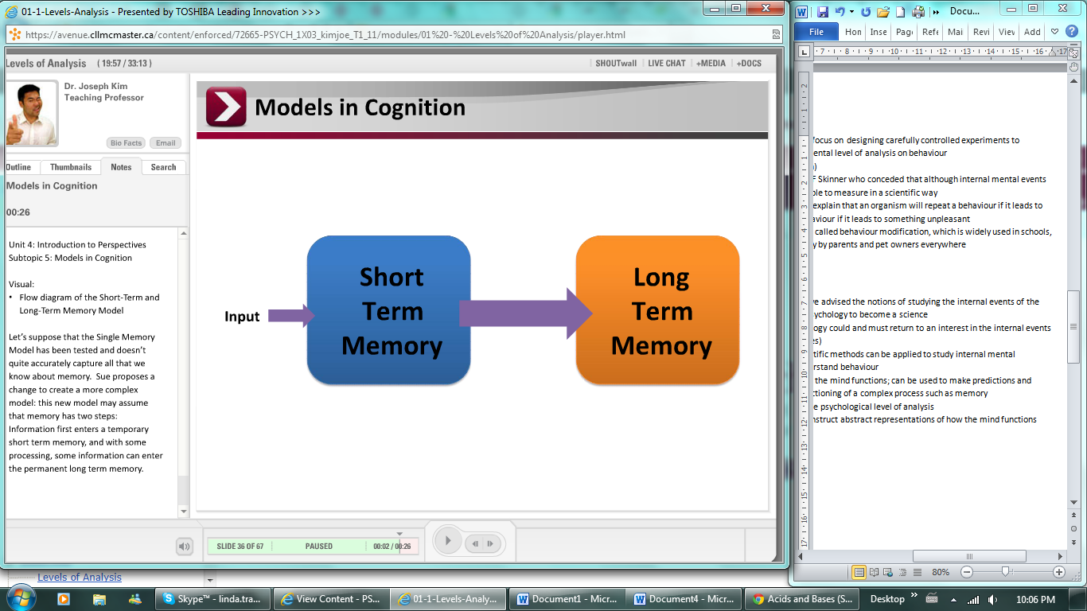  
-from models (simple at first), can be improved and built upon as new evidence appears

**Module: The Biological Perspective and Reductionism**

**Subtopic: The Biological Perspective and Reductionism  
-Reductionism:** all human behaviour can be reduced to the biology of the brain; our understanding of the brain is incomplete

**Subtopic: Introduction to Neuroimaging**-modern techniques in neuroimaging allow psychologists to use less invasive procedures to look at the brain and examine it while the subject is fully awake  
-*structural neuroimaging* allows us to see the physical make-up of the brain, while *functional neuroimaging* allows us to see what the brain is actually doing (useful for different questions)

**Module: Evolutionary and Developmental Perspectives**

**Subtopic: Evolutionary and Developmental Perspectives**-psychologist adopting an evolutionary perspective wants to explore the ultimate cause: Does it make adaptive sense for men to be more aggressive than women? Do levels of aggression have an important role in competition and survival in an evolutionary context?  
-developmental psychologists focus on how genetic and environmental factors contribute to changes in behaviour across a lifespan   
-evolutionary psychologists are similarly interested in the influence of genetic and environmental factors, but consider much larger periods of time—thousands, if not millions of years across the history of a species

**Subtopic: Methods in Developmental Research  
-**developmental researchers in particular face unique challenges when studying a special population of individuals  
-perform test; show babies same image over and over, until bored; if new photo is showed and baby’s expression lights up, baby has identified the different image

**Module: The Socio-Cultural Perspective**

**Subtopic: The Socio-cultural Perspective  
-**socio-cultural perspective focuses on how individuals are influences by culture and interactions with other people  
-typically, psychologists adopting this perspective are interested in one of three things:   
**• the influence of an individual on a group  
• the influence of a group on an individual  
• the influence of one group on another group**

**Subtopic: Understanding Depression— A Behaviourist Perspective  
­-**one behaviourist view of depression is inspired by animal research on a phenomenon called learned helplessness  
-through repeated trials, subjects have learned that they are unable to escape from similar situations in the future  
-learned that they are “helpless” and don’t try to escape even when there is a clear course of action to avoid the unpleasant stimulus

**Subtopic: Understanding Depression—Other Perspectives**-naturally, psychologists adopting one of the other perspectives discussed, would be motivated by different questions and directions for research  
-cognitive psychologist would seek to learn something different than a colleague with a more biological perspective, who in turn would be interested in something different from a colleague following an evolutionary perspective